**DAILY ASSESSMENT FORMAT**

|  |  |  |  |
| --- | --- | --- | --- |
| **Date:** | **03/07/2020** | **Name:** | **Yashaswini.R** |
| **Course:** | **Satellite Photogrammmetry and its Applications** | **USN:** | **4AL17EC098** |
| **Topic:** | **Programmetric products from satellite stereo images** | **Sem& Section:** | **6th sem ‘B’ sec** |
| **Github Repository:** | **Yashaswini** |  |  |

|  |
| --- |
| **AFTERNOON SESSION DETAILS** |

**IMAGE OF SESSION**

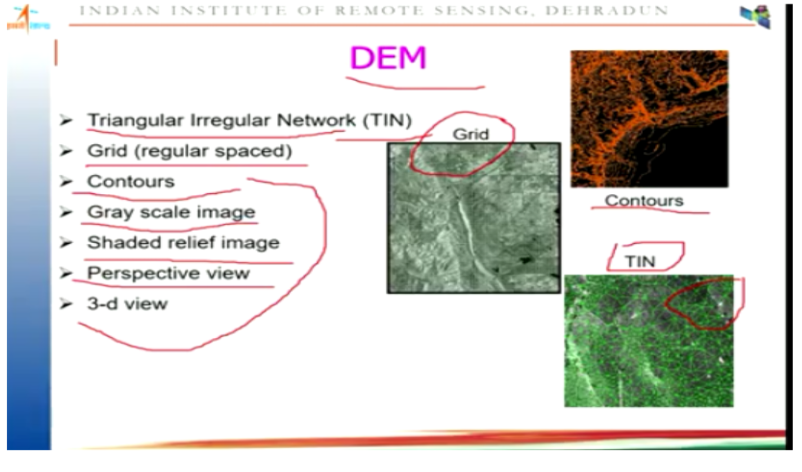

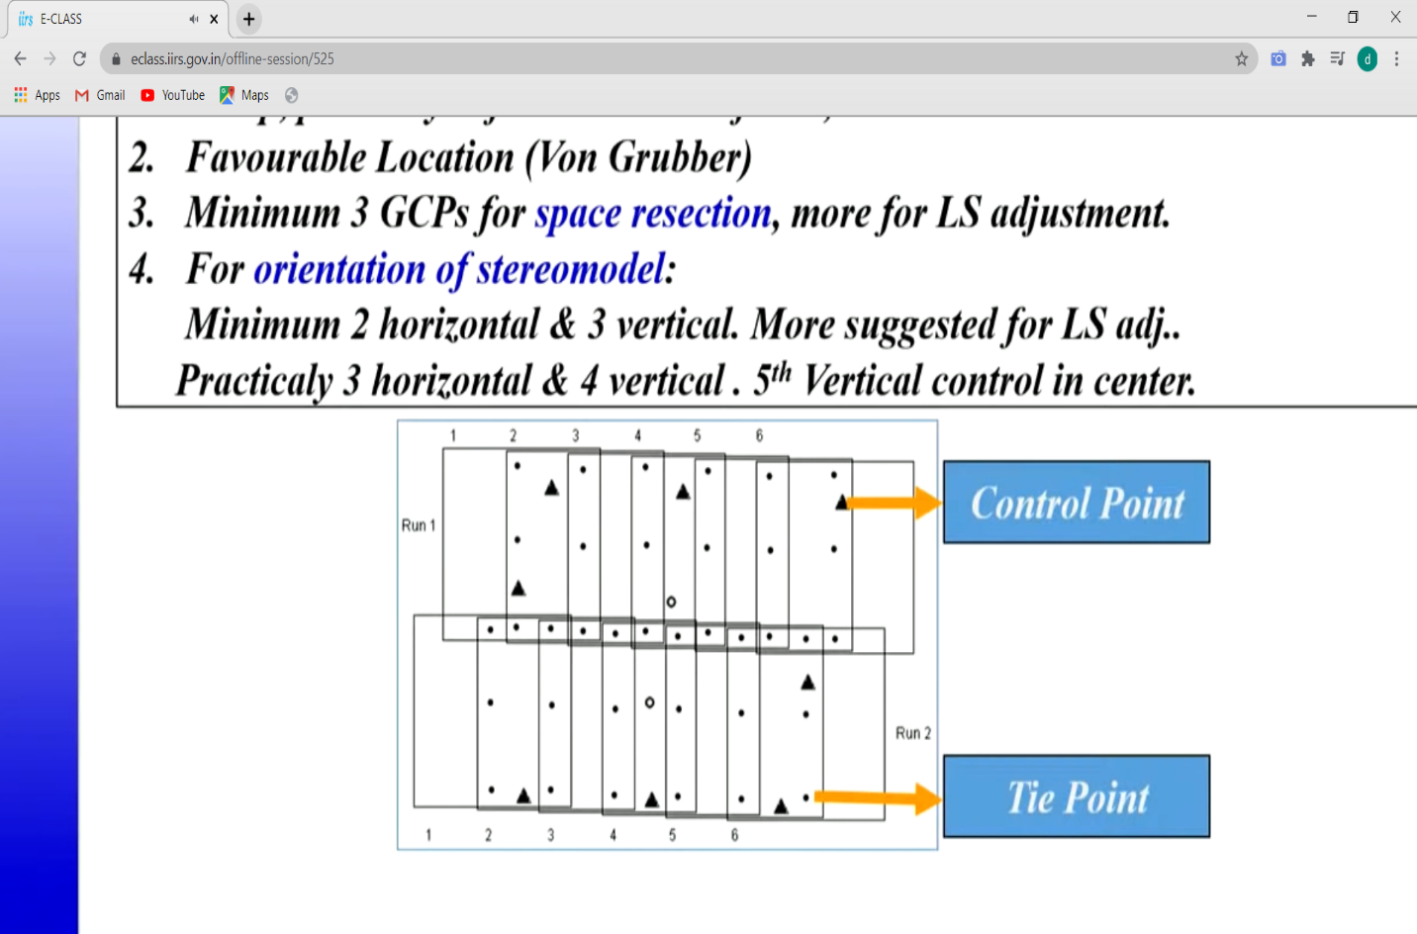

The Basic manipulations that can be done with ArcMap.

This involves tools under Spatial Analyst ,

**Surface** (the Spatial Analyst extension needs to be turned on in order for this to work properly).

* **Slope:** The DEM can easily be transformed into a slope map with the Slope tool.This map describes the slope for each raster cell in degrees based on the elevation at each point.
* **Aspect:** Another derivative is the aspect map .This map displays the aspect of each raster cell grouped into compass directions (north, northwest, etc.).
* **Hillshade:** This tool creates a map with a shade-effect based on the input parameters that are entered in the tool. The resulting map is easier to interpret than the original DEM, because some topographic features are better visible.
* **Curvature:** The curvature map is calculated by using the curvature tool. This basically calculates the relative change in slope, could be seen as a second order DEM derivative.
* **Contour:** Topographic contour lines can be plotted with the contour tool. Based on the user defined parameters the new map will display contour lines.
* **Viewshed & Observer Points:** These tools are used to calculate a position relative to a user defined feature. This is useful to determine the visibility of a location.
* **Select attribute:**By inserting a query and selecting a threshold, it is possible to select certain elevations on the map and display the location of these points.

**In-Depth Analysis:**

* DEMs are good for landscape analysis.
* There are many more advanced and specialized functions and applications in ArcMap that can be used for analysis.
* This includes, but is not limited to, hydrologic analysis, geologic and geomorphic analysis and landscape development.
* It is also possible to do calculations with raster data.
* The DEM elevation values can be used for this, but another option is to reclassify the map and give each class a certain value that is used in a function.
* This can easily be displayed in a model, which can also be made in ArcMap.
* The DEM is a very useful feature in the geospatial analysis. It is used for many research fields and can be manipulated in many ways. The possibilities described in this GIS in Practice are just a summary of all possibilities of a single DEM.